Steps for Peace

Sunday 17th November 12.15 – 4.30 pm
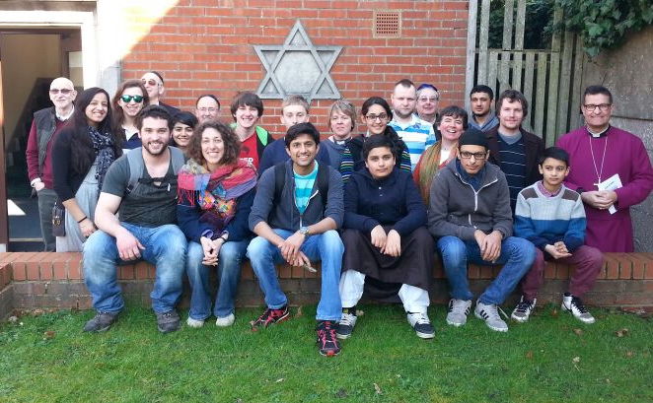

A walking tour around Southampton, visiting different places of worship including a Vedic Temple, a Gurdwara, a Mosque, a Greek Churches, learning about some of the many faiths of the city. Experience some of the culture and food from the different communities…
Are you coming??
Meet at Queens Peace Fountain in East Park
at 12.15 (near Jurys Inn)
For more information go to
www.southampton-faiths.org

